**CS 5710**

**Machine Learning (Assignment # 1)**

E-mail: [gxm04390@ucmo.edu](mailto:gxm04390@ucmo.edu)

Name: Mogalapu Gideon Jaideep Sudarshan

Course: CS 5710

Assignment: Assignment 1

Git Hub: <https://github.com/JaideepMogalapu/Assignment1>

Video Link : <https://drive.google.com/drive/folders/1e_ZKv8C5lChsuvw4G3wA-rF1ydfCvgjl?usp=share_link>

**Question 1**

**Description:** Created the list named ages. Sorted the list and found the min and max ages. Found the median and average (sum of all items divided by their number) and range of the ages (max minus min)

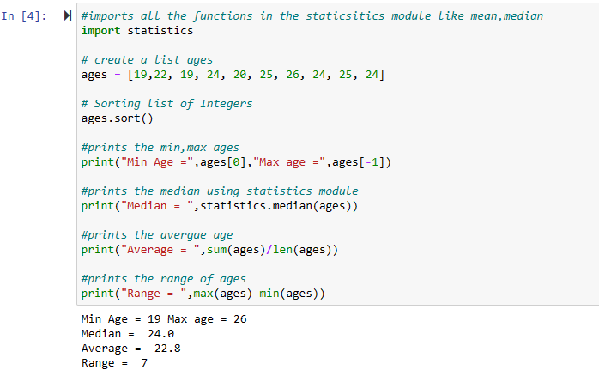

**Question 2**

**Description:** Created dog, which is empty dictionary and added name, color, breed, legs, age to the dog dictionary. Created student dictionary and add first_name, last_name, gender, age, marital status, skills, country, city and address as keys for the dictionary. Get the length of the student dictionary, value of skills, and check the data type, it should be a list. Modified the skills values by adding one or two skills

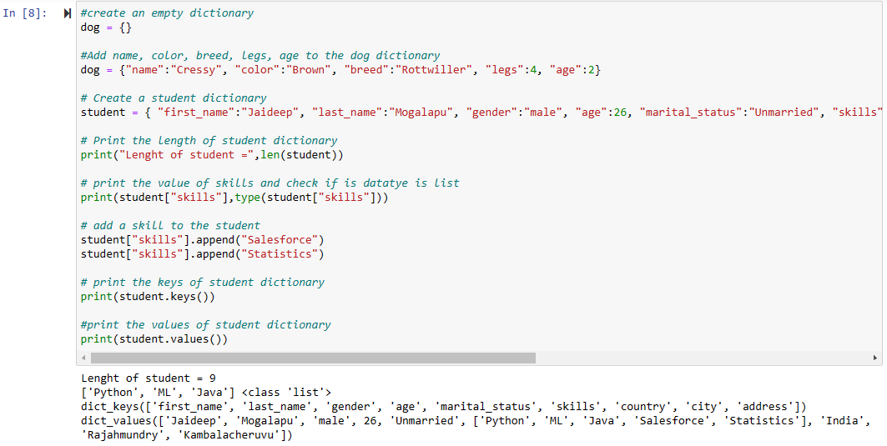

**Question 3**

**Description:** Created tuple containing names of sisters and brothers and Joined brothers and sisters tuples and assigned it to siblings and modified the siblings tuple and added the name of father and mother and assigned to family_members

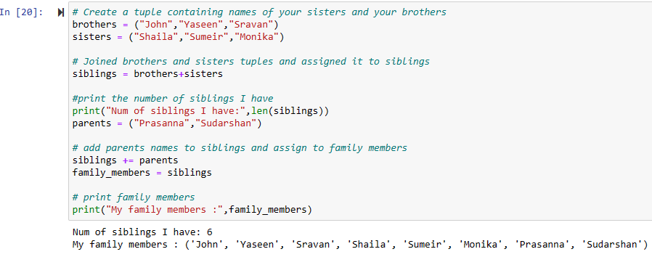

**Question 4**

**Description:** Identified the length of the set it_companies. Added twitter and inserted multiple companies to the set it_companies. Joined A and B and found the symmetric difference between A and B, if the set is a disjoint and subset. Deleted the sets completely. Converted the ages to a set and compared the length of the list and the set.

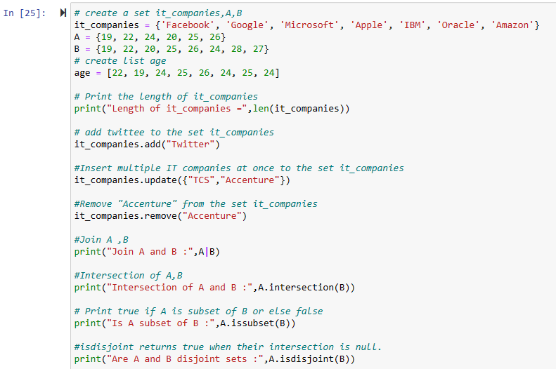

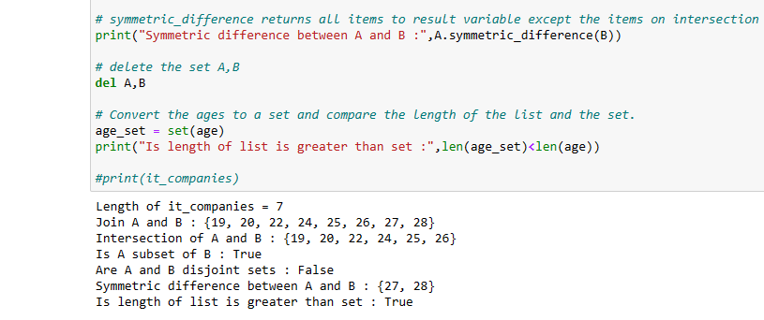

**Question 5**

**Description:** Given radius of a circle is 30 meters. Calculated the area of a circle and assigned the value to a variable name of _area_of_circle_. Print the area and circumference of the circle.

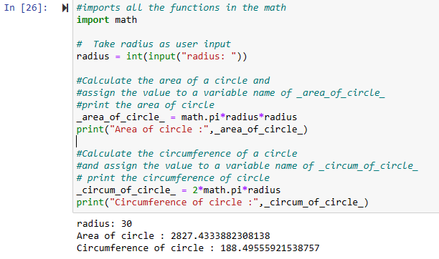

**Question 6**

**Description:** Given string is “I am a teacher and I love to inspire and teach people”. Used the split method and sets to get the unique words and count of them

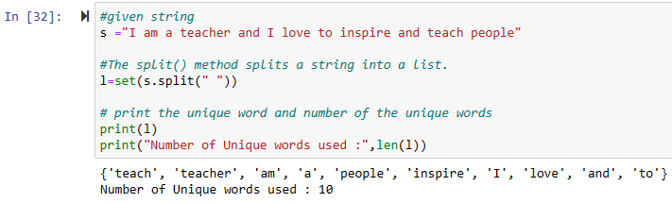

**Question 7**

**Description:** Used a tab escape sequence to get the following output.

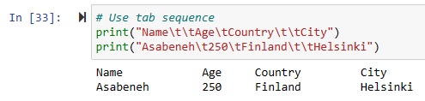

**Question 8**

**Description:** Using the string formatting method I have displayed the following:

radius = 10

area = 3.14 * radius ** 2

The area of a circle with radius 10 is 314 meters square.

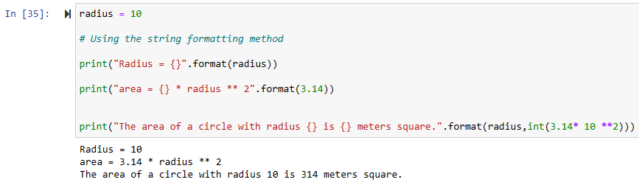

**Question 9**

**Description:** Executed the program, which reads Number of students and their weights (lbs.) into a list and convert these weights to kilograms in a separate list using Loop and functions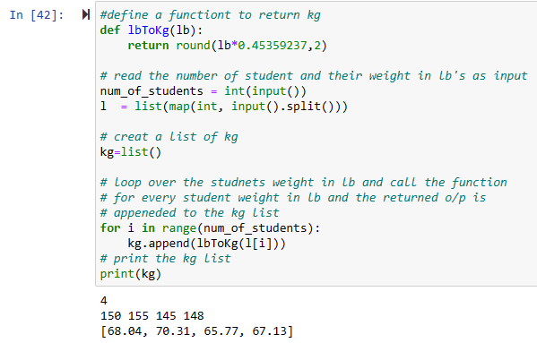

**Question 10**

**Description:**

**1)** **what would be the predicted outputs for the test samples**

**Given Values:**

|  |  |
| --- | --- |
| **f** | **o/p** |
| 1 | dot |
| 2 | dot |
| 3 | cross |
| 6 | cross |
| 6 | cross |
| 7 | dot |
| 10 | dot |
| 11 | dot |

**Divide into two equal parts**

**1) training set**

|  |
| --- |
| **f** |
| 1 |
| 2 |
| 3 |
| 6 |

**2) testing set**

|  |
| --- |
| **f** |
| 6 |
| 7 |
| 10 |
| 11 |

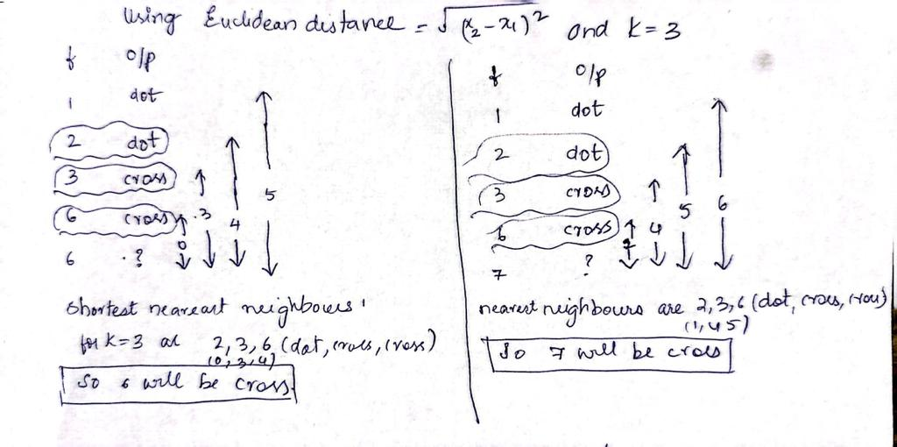

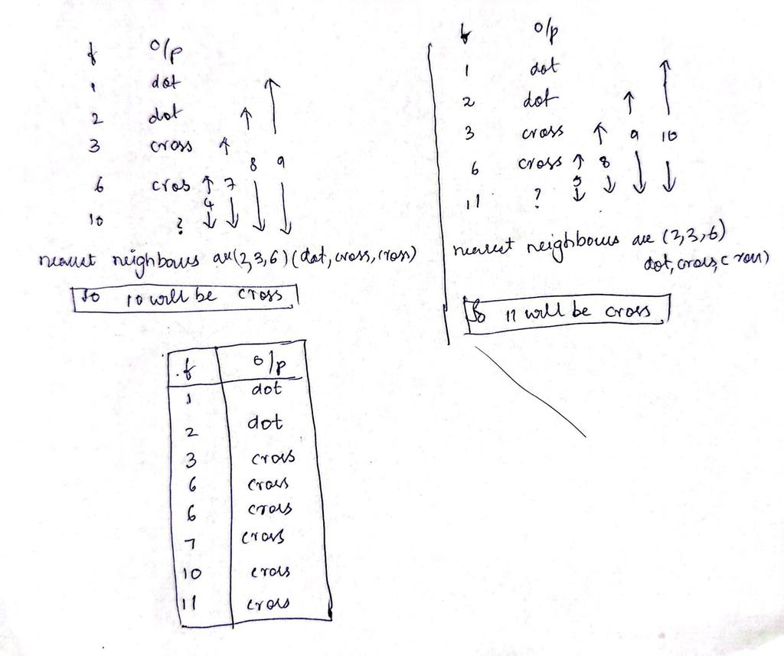

The predicted outputs for the test samples

|  |  |
| --- | --- |
| **f** | **o/p** |
| 6 | Cross |
| 7 | Cross |
| 10 | cross |
| 11 | cross |

**2) Calculate confusion matrix for this and calculate accuracy, sensitivity, and specificity values**

**Confusion Matrix** = [ [1 0]

[3 0] ]

TN= 1 ; FP = 0 ; FN = 3 ; TP = 0

**Accuracy = (TP+TN)/(P+N)**

= (0+1)/ (1+0+3+0)

= 1/4

= 0.25

**Sensitivity or true positive rate (TPR) = TP/ (TP+FN) = TP/P**

= 0/ 0+3

= 0

**Specificity or TNR = TN/ (FP+TN) = TN/N**

= 1/ (0+1)

= 1

**1) Accuracy = 0.25**

**2) Sensitivity = 0**

**3) Specificity = 1**